|  |  |
| --- | --- |
| **Computer Science 1** | **Lab 06C**  **Practice/Perform Major Python Assignment** |
| **The Graphics Library Program II** | **50, 60, 70, 80, 90, 100 & 110 Point Versions** |
| **Assignment Purpose:**  The purpose of this program is to reinforce knowledge of calling, and using correct argument passing with several of the procedures from the **Graphics** library. | |

You will write another program, which displays several geometric designs using the provided **Graphics** library. The difference between this lab, and **Lab 06B**, is that you do not know what these geometric designs will be ahead of time. Also, you do not get separate practice day for this lab. You practiced when you did **Lab 06B**. As before, you will be provided with a skeleton program. Your job still is to use the proper procedures from the **Graphics** library along with the correct argument values to match the output shown on this assignment – which will be provided by your teacher when you do this for a grade. Remember, students are still allowed to refer to the **Graphics Library Reference** document while practicing AND when they do the lab for a grade. The first couple pages of the document are shown below. The entire document can be found in the **IntroCS-Graphics Files** subfolder of your **LearnIntroCS** folder.

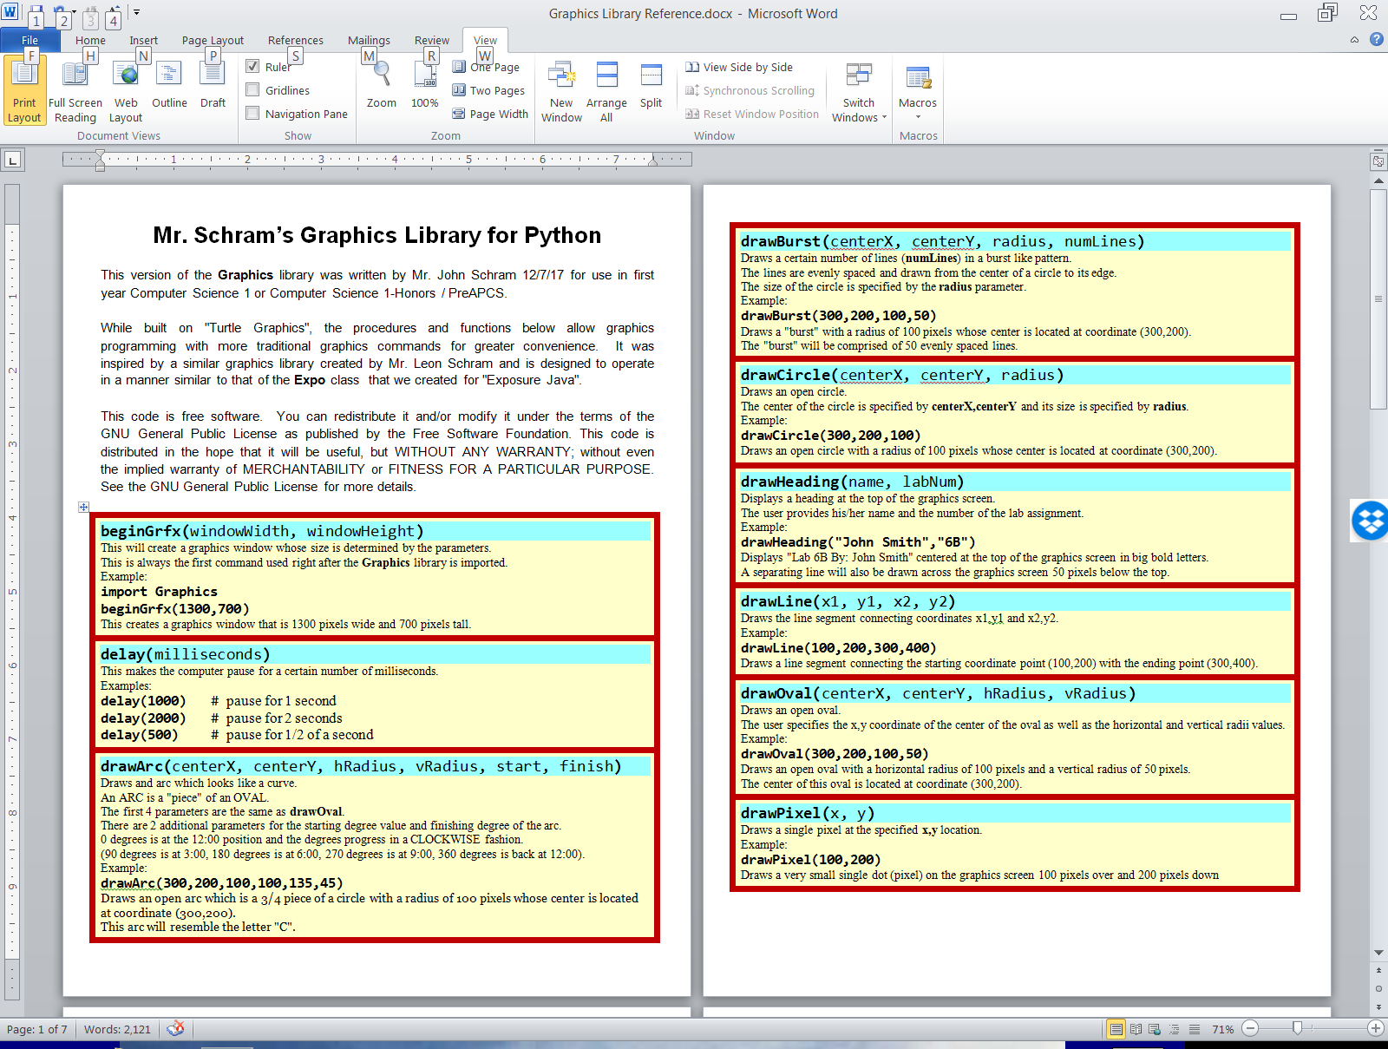

|  |  |
| --- | --- |
| **Lab 06C Student Version** | **Do not copy this file, which is provided.** |
| **1 # Lab06Cst.py  2 # "The Graphics Library Program II"  3 # This is the student, starting version of Lab 06C.  4   5   6 from Graphics import *  7   8 beginGrfx(1300,700)  9  10 # Substitute your own name here. 11 drawHeading("John Smith","6C") 12  13  14  15  16  17  18  19  20 endGrfx() 21** | |